Project Objective: Design & populate an [IMDb](http://www.imdb.com/) database

Database Design Requirements:

* Use IMDb web pages or mobile interface to identify entities and relationships (list below)
* Identify IMDb “page”
  + list entities and relationships on that page
  + list entities related on pages linked to that page

Data Source:

* Use [IMDb Alternative Interfaces](http://www.imdb.com/interfaces) and/or input sample data for each entity

List of IMDb application “pages” to use for requirements:

* 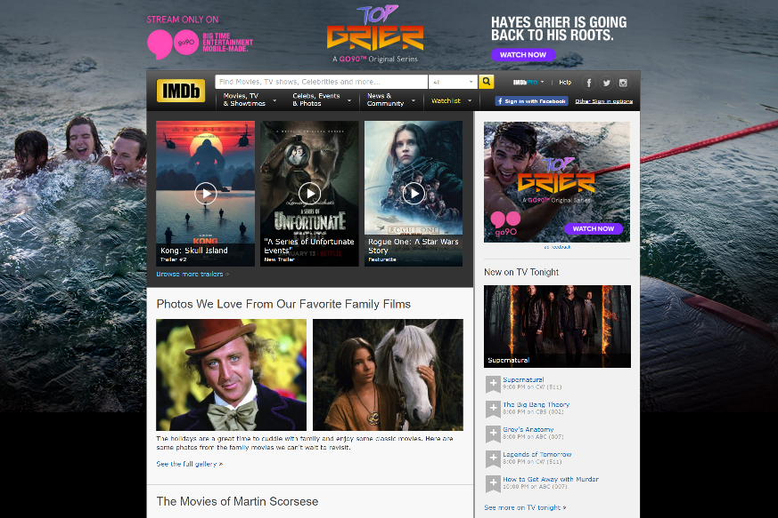[Home](http://www.imdb.com/?ref_=nv_home)
* Movies
  + [In Theaters](http://www.imdb.com/movies-in-theaters/?ref_=nv_mv_inth_1)
  + [Showtimes & Tickets](http://www.imdb.com/showtimes/?ref_=nv_mv_sh_2)
  + [Latest Trailers](http://www.imdb.com/trailers/?ref_=nv_mv_tr_3)
  + [Coming Soon](http://www.imdb.com/movies-coming-soon/?ref_=nv_mv_cs_4)
  + [Release Calendar](http://www.imdb.com/calendar/?ref_=nv_mv_cal_5)
  + [Top Rated Movies](http://www.imdb.com/chart/top?ref_=nv_mv_250_6)
  + [Most Popular Movies](http://www.imdb.com/chart/moviemeter?ref_=nv_mv_mpm_8)
* Charts & Trends
  + [Box Office](http://www.imdb.com/chart/?ref_=nv_ch_cht_1)
  + [Oscar Winners](http://www.imdb.com/search/title?count=100&groups=oscar_best_picture_winners&sort=year,desc&ref_=nv_ch_osc_2)
  + [Most Popular by Genre](http://www.imdb.com/genre/?ref_=nv_ch_gr_3)
* TV & Video
  + [On Tonight](http://www.imdb.com/tvgrid/?ref_=nv_tvv_ls_2)
  + [Top Rated TV Shows](http://www.imdb.com/chart/toptv/?ref_=nv_tvv_250_3)
  + [Most Popular TV Shows](http://www.imdb.com/chart/tvmeter?ref_=nv_tvv_mptv_4)
  + 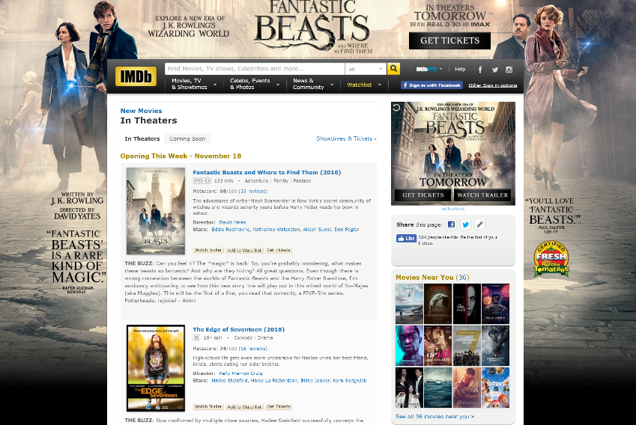[Watch Now on Amazon](http://www.imdb.com/feature/watch-now-on-amazon/?ref_=nv_tvv_wn_5)
  + [DVD & Blu-Ray](http://www.imdb.com/sections/dvd/?ref_=nv_tvv_dvd_6)
* Celebs
  + [Celebrity News](http://www.imdb.com/news/celebrity?ref_=nv_cel_nw_2)
* Events
  + [Awards Central](http://www.imdb.com/awards-central/?ref_=nv_ev_awrd_1)
* News
  + [Top News](http://www.imdb.com/news/top?ref_=nv_nw_tp_1)
  + [Movie News](http://www.imdb.com/news/movie?ref_=nv_nw_mv_2)
  + [TV News](http://www.imdb.com/news/tv?ref_=nv_nw_tv_3)
  + [Celebrity News](http://www.imdb.com/news/celebrity?ref_=nv_nw_cel_4)
  + [Indie News](http://www.imdb.com/news/indie?ref_=nv_nw_ind_5)
* Community
  + [Polls](http://www.imdb.com/poll/?ref_=nv_cm_pl_3)

Deliverables:

* Create ER model for entities and relationships identified in your design requirements
* Use TOAD Data Modeler to document
  + Submit TOAD data model file
  + Submit images of ER model (or sub-models)
* Create databases to implement your ER model
  + Microsoft SQL Server
  + Oracle
  + Hive
* Database Design
  + Submit list of tables & columns
  + Submit list of indexes, triggers, constraints or other dataset objects
* Load sample data into each of your databases
* Create a list of questions a IMDB user might be searching for when using IMDb application
* Create SQL queries to answer the above questions for both SQL Server & Oracle
  + Submit questions to be answered, SQL queries and query result set